Chapter 1 Exercises
Lien Chen July 17
- Find a source for the historical securitization rates of mortgages in the US. What has been the range of the securitization rate? Was there a particular juncture in time after which it noticeably changed? Can you explain why?

According to the data from year 2001 to 2006, the securitization rates kept increase, while the origination amount reached its peak in 2003. That was due do the reduction in long-term interest rates through the end of 2003. After 2003, the sub-prime market continued rapid growth through 2005. However, if we can get data after 2006, a sharp decline might be expected after financial crisis.
 | Sub-prime |  |  | Non-agency |  |  | Agency
Year | Origination | Issuance | Ratio | Origination | Issuance | Ratio | Origination | Issuance | Ratio
2001 | 87.1 | 190 | 46% | 430 | 142.2 | 33% | 1,433.00 | 1,087.60 | 76%
2002 | 122.7 | 231 | 53% | 576 | 171.5 | 30% | 1,898.00 | 1,442.60 | 76%
2003 | 195 | 335 | 58% | 655 | 237.5 | 36% | 2,690.00 | 2,130.90 | 79%
2004 | 362.63 | 540 | 67% | 515 | 233.4 | 45% | 1,345.00 | 1,018.60 | 76%
2005 | Sub-prime | 625 | 74% | 570 | 280.7 | 49% | 1,180.00 | 964.8 | 82%
2006 | 448.6 | 600 | 75% | 480 | 219 | 46% | 1,040.00 | 904.6 | 87%

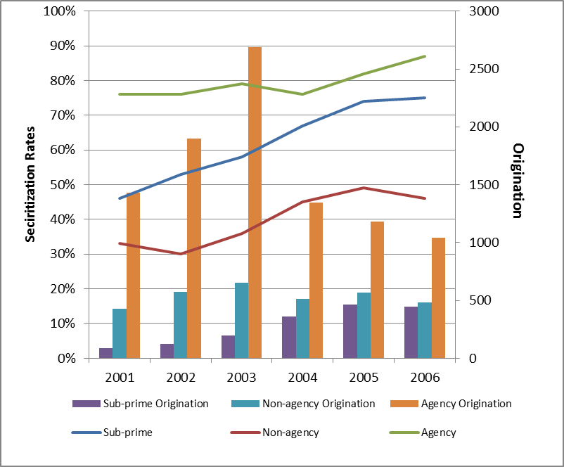

- Plot the historical contribution of residential fixed investment to GDP. Currently, how much is residential fixed investment contributing to GDP growth?

The following is the historical contribution of residential fixed investment to GDP data:
 | Gross domestic product | Real estate | Percent
1997 | 8608478 | 1044497 | 12.1
1998 | 9089133 | 1083165 | 11.9
1999 | 9665696 | 1174978 | 12.2
2000 | 10289748 | 1243425 | 12.1
2001 | 10625252 | 1340276 | 12.6
2002 | 10980187 | 1412026 | 12.9
2003 | 11512237 | 1465427 | 12.7
2004 | 12277037 | 1534600 | 12.5
2005 | 13095426 | 1649715 | 12.6
2006 | 13857893 | 1722442 | 12.4
2007 | 14480312 | 1837349 | 12.7
2008 | 14720254 | 1896998 | 12.9
2009 | 14417942 | 1904458 | 13.2
2010 | 14958261 | 1942946 | 13.0
2011 | 15533839 | 2000103 | 12.9
2012 | 16244586 | 2094395 | 12.9
2013 | 16799735 | 2178614 | 13.0

We can see from the chart, residential investment contribution growth from 12.1% in 1997 to 13.0% last year. Last year residential investment stands for 15.17% to total GDP growth.

- Download historical rates of equity extraction from Freddie Mac and plot them. Why was there such a big change in this series recently?

According to the Freddie Mac Cash-Out Refinance report, the trend shows as:

We can see a big change during 2003 to 2009. It increased to 29.28% in 2006 then sharply declined to 8.03% in 2009.

The reason is equity extraction is highly correlated with house market. We plot a detail graph as below, which clearly shows the similar trend shared by equity extraction rate and HPI.
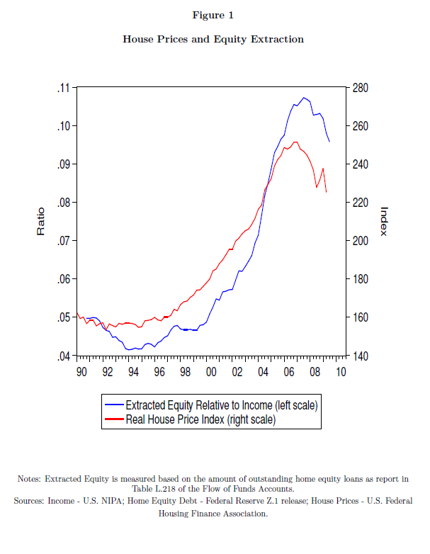

- What is the correlation between OER and core CPI since 1985

We use OER and CPI data from 1985 to 2014. Since CPI shows a monotonic increase trend while OER shows volatile decrease, we cannot see a clear correlation.
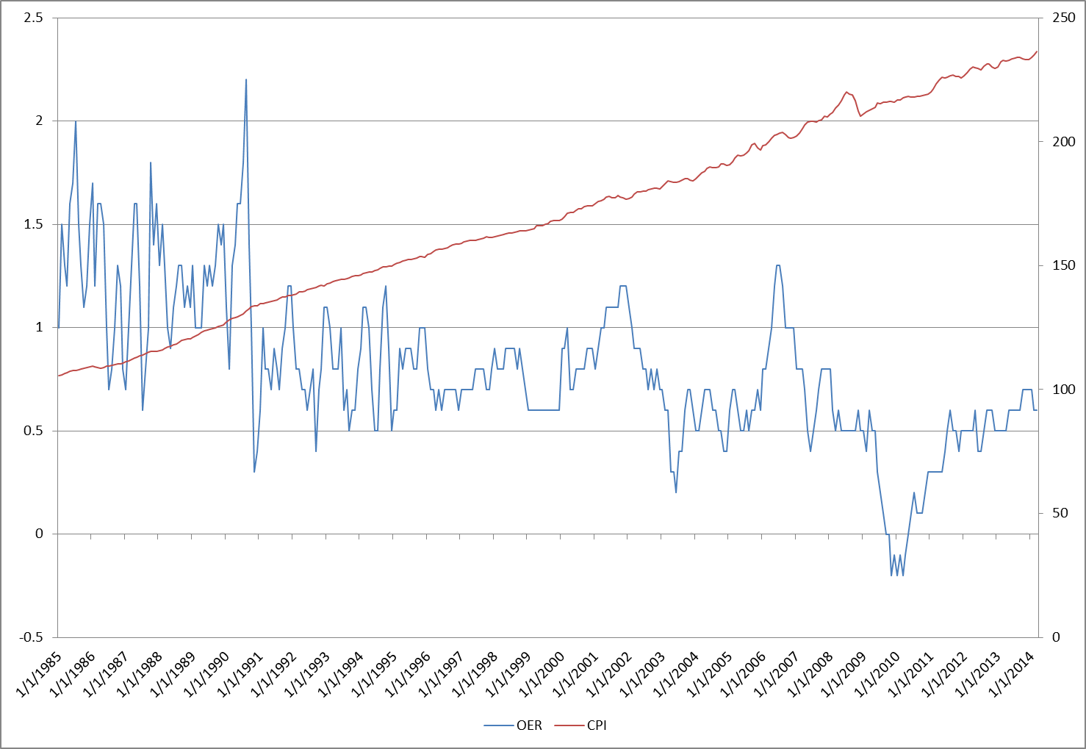
So I calculated the first order difference for CPI:
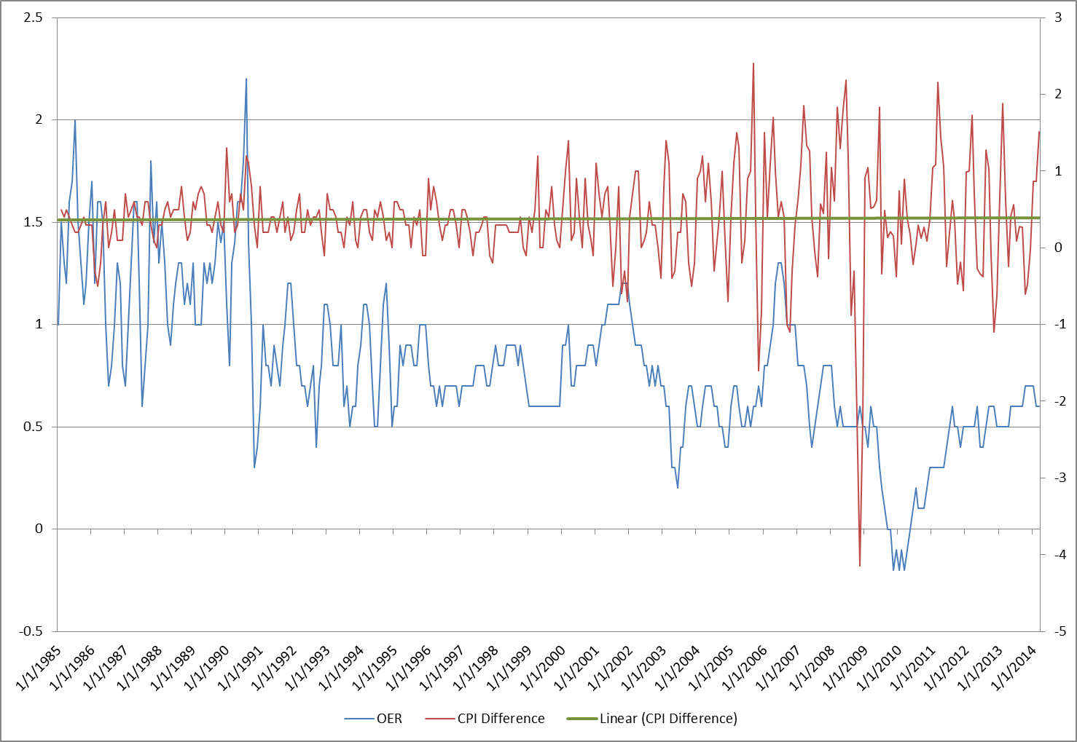
The result shows a high volatility in CPI first order difference and the linear regression result also show it ​​fluctuate around the mean. This two series have a correlation of 1.219.

I also checked the increase rate as the second order difference of CPI:
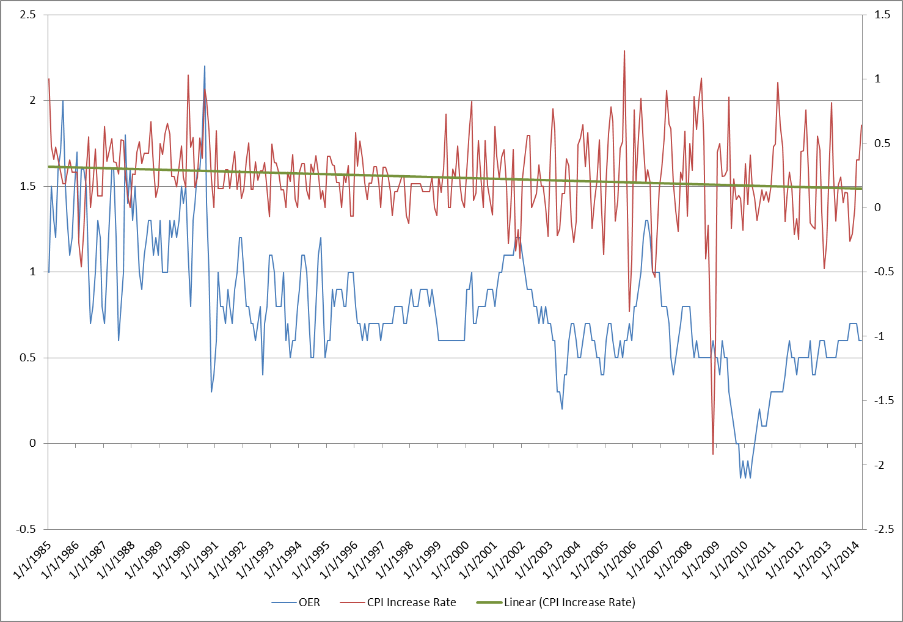
The correlation is still quite low, 0.1178.

I guess the results do not show that OER is a good explainer factor of CPI.

- Plot house price versus OER since 1990. What is the correlation between these two series? Can you explain why this might be the case?

We plot the OER and house price as below
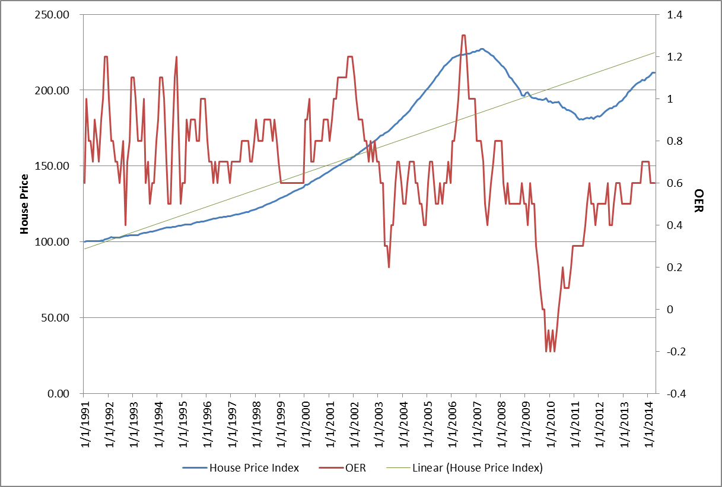
House price shows an increase trend which we might need to remove. (Trend is showed as the blue line as the linear regression result)

After de-trend, we can see a good correlation between HPI-detrend and OER.
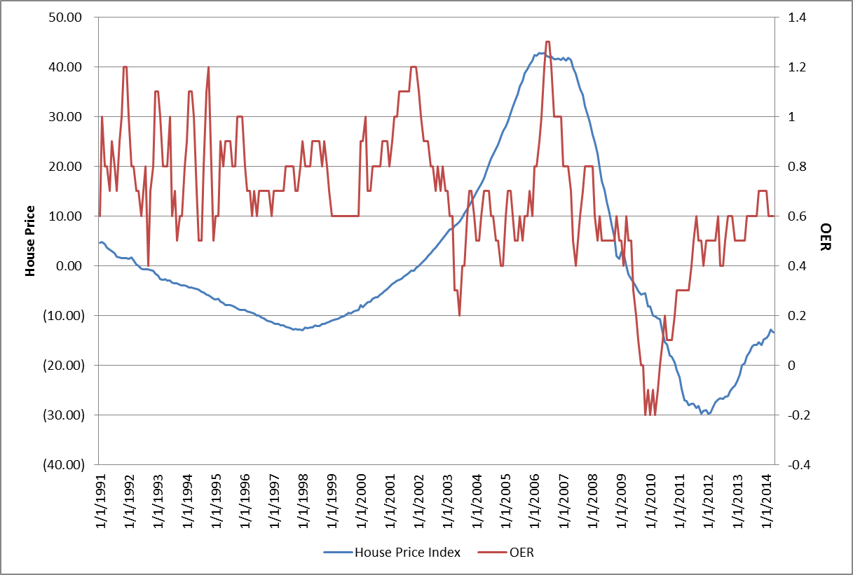
The HPI curve fit OER well after 2002. Correlation between them is 0.489372.

The reason behind is the home owners have to pay/earn more for renting, when house price go down/up.

